Introduction:
The availability of energy has transformed the course of humanity in many ways over the last few centuries. We have continuously found new ways of harnessing the energy. At first, we have extracted the energy from Fossil Fuels Followed by Nuclear and then Renewable Energy. Due to the development of technology and increase in population, demand for energy has increased. There is a lot of research and development going on in finding the new sources of energy and to improve the existing technologies.
During the industrial revolution there is exponential increase in the energy consumption. During this time, we have consumed energy with no regard towards the environment. As the extraction and processing of fossil fuels is becoming harder and it was not able to meet the needs, the world has started searching for new ways and that’s when we have found the nuclear energy. The nuclear energy is dangerous and has side effects on health, but it is easy to produce the energy.
Global warming has alarmed us and made us to re-think on our approach towards the energy. This led to the invention of Renewable energy. Production of Renewable energy has zero harmful effects on earth. The entire world has started focusing on research and development of Renewable energy.
I believe the following analysis will show us on how the world is performing on its energy consumption.
- Compare Energy consumed by all the countries w.r.t Population and GDP.
- Compare different Sources from which the energy was generated Like Fossil Fuels, Renewable sources, Nuclear or Hydro Electricity.
- Different countries installed capacities for different types of renewable energy.

Methodology:
The datasets that I am using has been taken from different government and open source websites.
World energy w.r.t continents and countries:
This data set has been taken from U.S government website (www.data.gov) .
Data source
This data set contains information on different types of energy consumed by each country over a span of 40 years (1980-2020). I have used excel operations to filter different types of energy and then Tableau prep builder to do Pivot and giving new column names.

GDP:
I have taken the GDP of each country for the same period (1980-2020) from the world bank data.
Data source GDP
This dataset has some null values. I have used Python code to replace these null values with mean of the entire row. Then I have used Tableau prep builder to clean and to do pivot.

Population:
I have taken this dataset from United Nations Organization.
Data Source-Population
I have removed some unwanted fields and cleaned the data set using tableau prep builder.

Analysis :
World Energy :
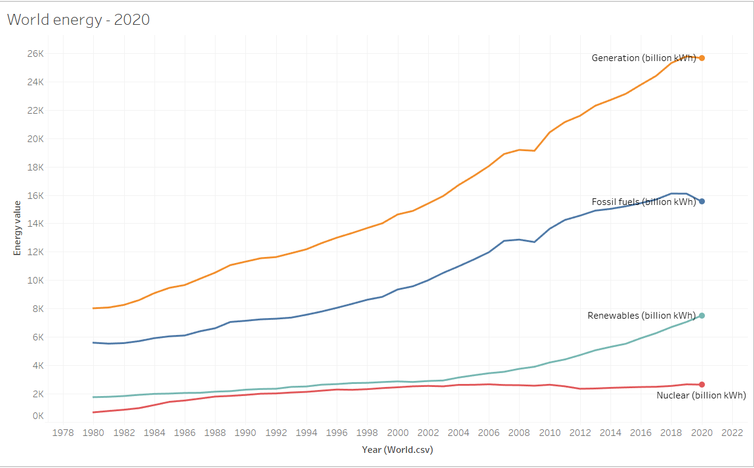

The above line graph shows us the total energy generated and different source from which it was produced over the span of 40 years. Upon observation the following conclusions can be made.
- The total energy generated has increased almost linearly from starting to ending.
- Most of the energy was from the Fossil Fuels and 20% from the Renewable sources and 5 percent from the nuclear.
- At starting there was not much change in the renewable energy production, But we could see there was exponential growth post 2003. The nuclear energy has been constant though out the time period. We could also see that total percent of fossil fuel energy has reduced.

Fossil Fuel Energy:
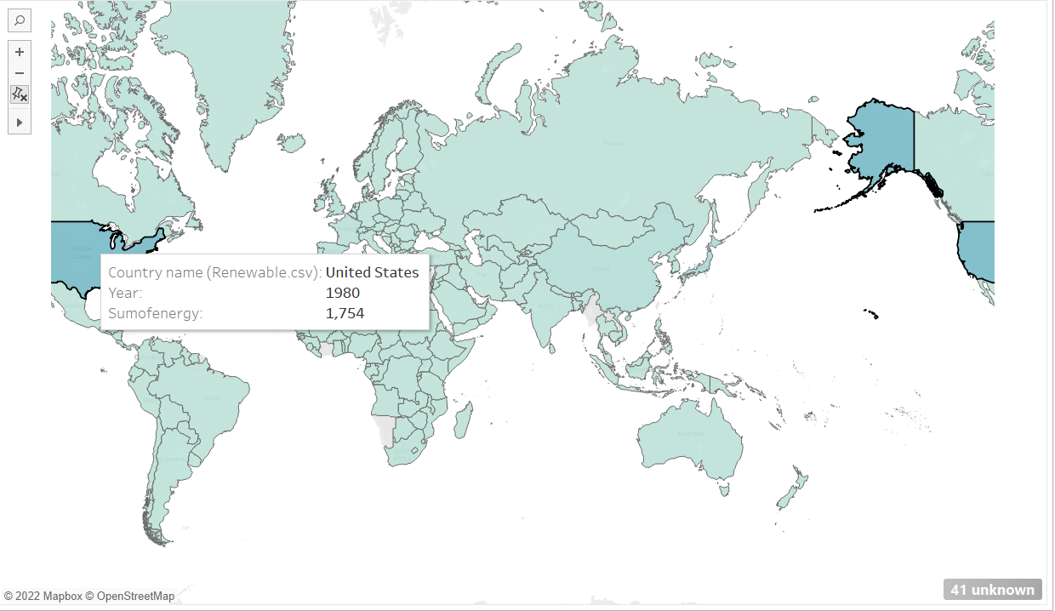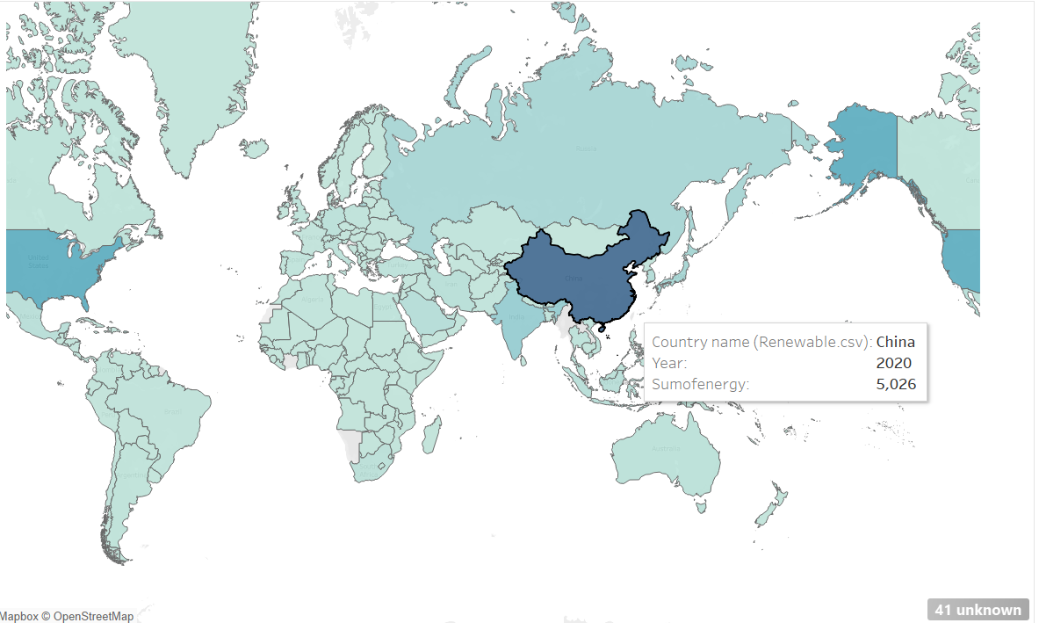

1980 2020
The above map shows us the Fossil Fuel energy consumed by each country animated from 1980 to 2020.
- At the starting USA has consumed the most fossil fuel energy with a value of 1754 billion KWH but by 2020 China became the country to consume more energy from Fossil Fuels with a value of 5026 billion kwh.

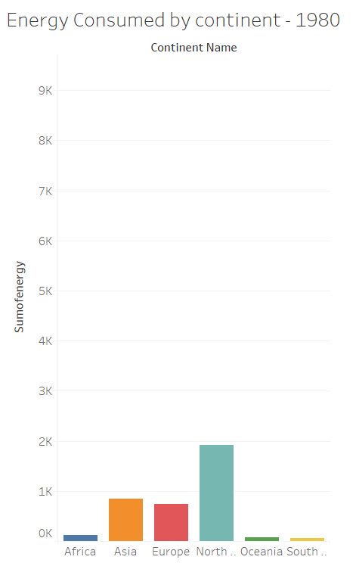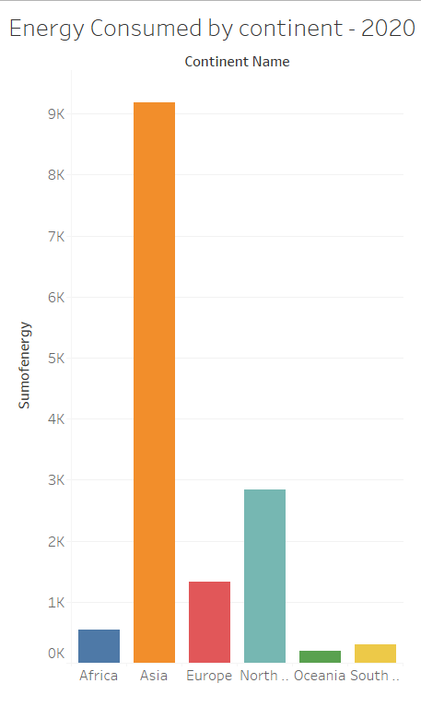

The above bar graph shows us the fossil fuel energy consumed for the year 1980 and 2020.
At the start North America has highest fossil fuel energy consumed followed by asia and Europe and by the year 2020 asia became the highest followed by North america and Europe.
when we normalize by dividing the energy with per capita income the results are as follows.
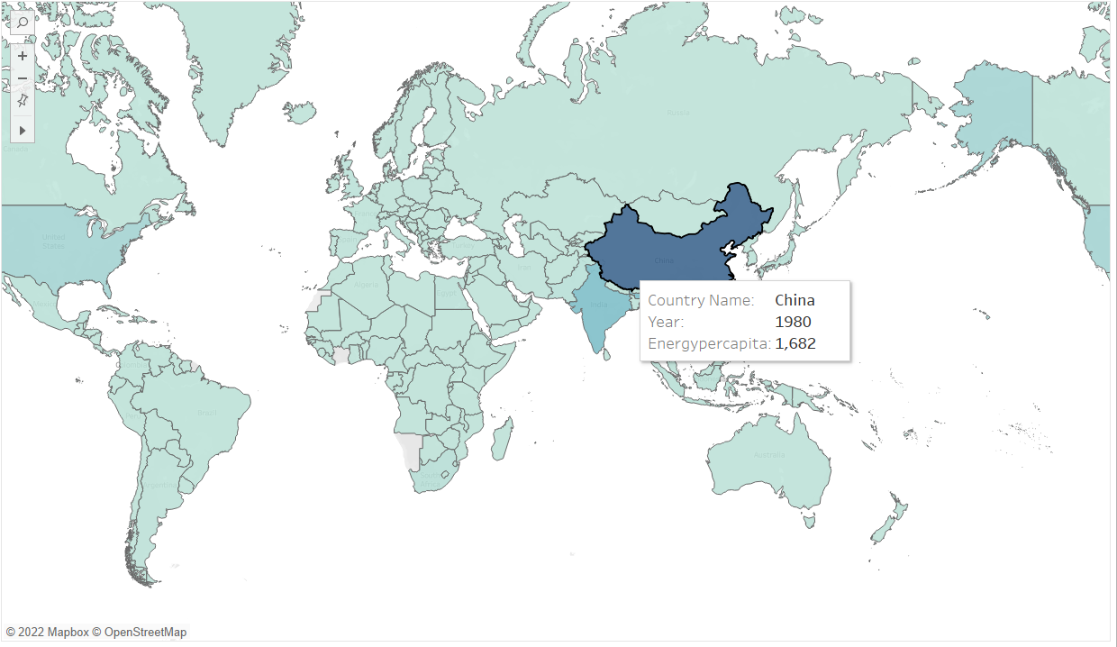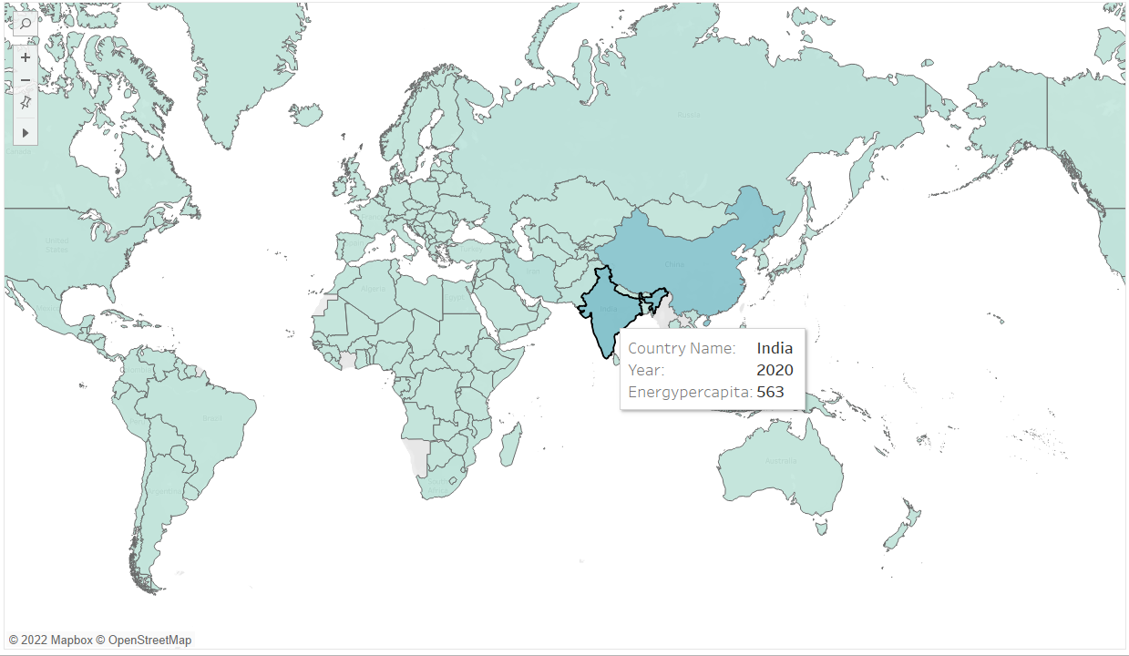
1980 2020

- From the above two maps we can see that during 1980 China became the highest Fossil Fuel energy consumed /per capita income and by 2020 India has become the highest. This is due to less GDP and more population in India.
Nuclear energy:
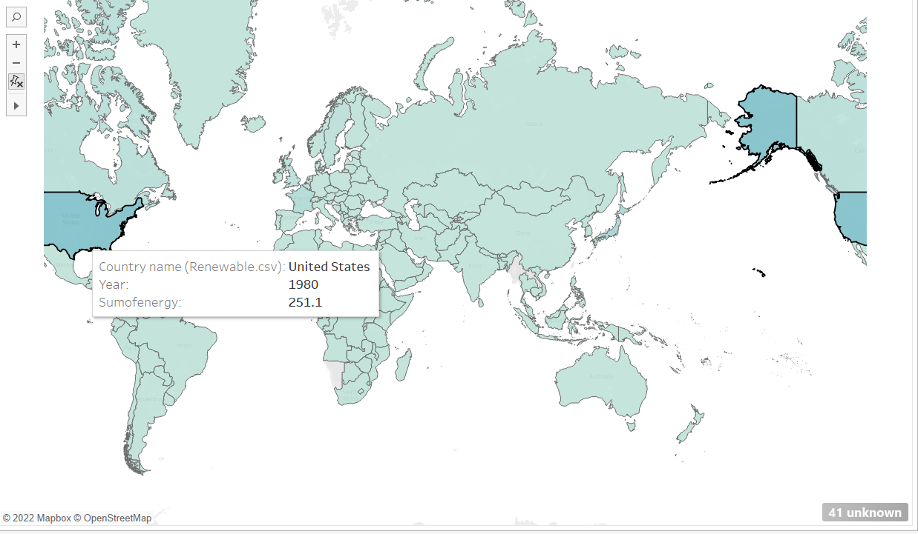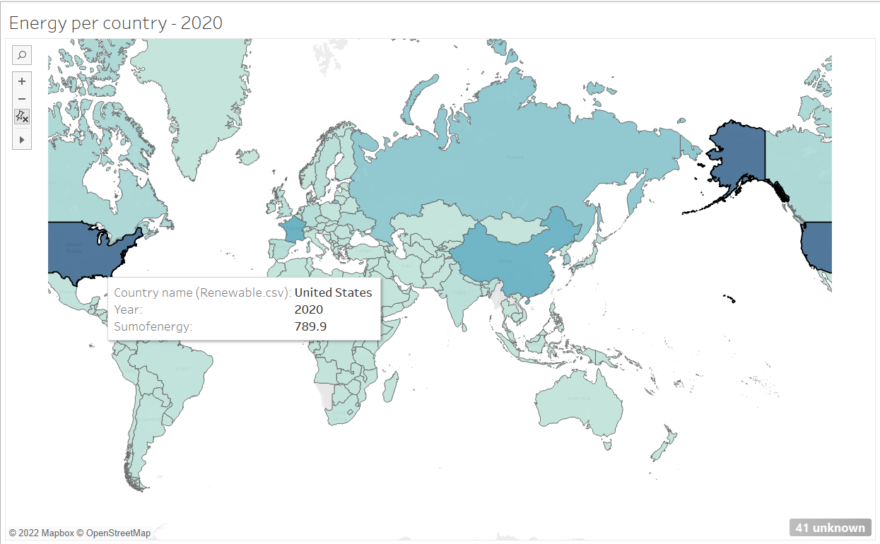
The First map shows us the nuclear energy consumed by each country in the year 1980 and the second map for 2020
- From the above maps we can say that USA became the country to consume highest nuclear energy with China in second position for most of the years from 1980 – 2020.
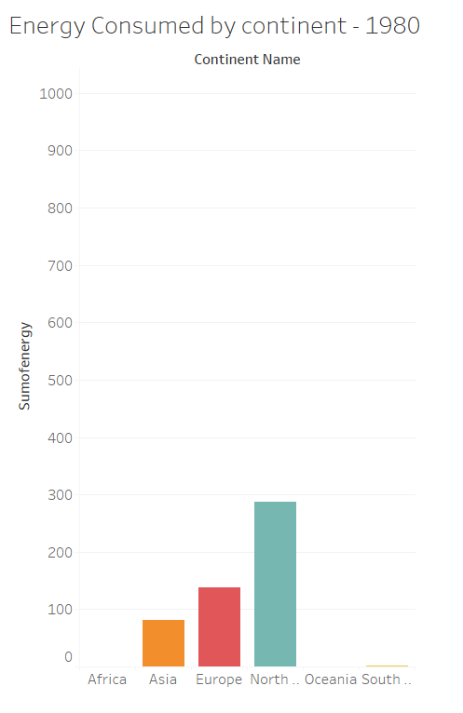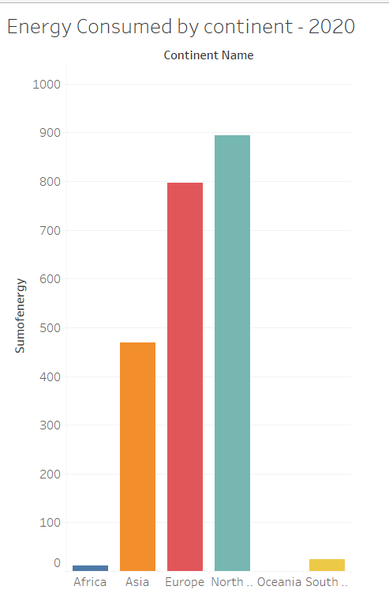
The bar graph shows us the Nuclear energy consumed for each continent.
- We can see that North america has the highest followed by europe and asia from 1980 – 2020.

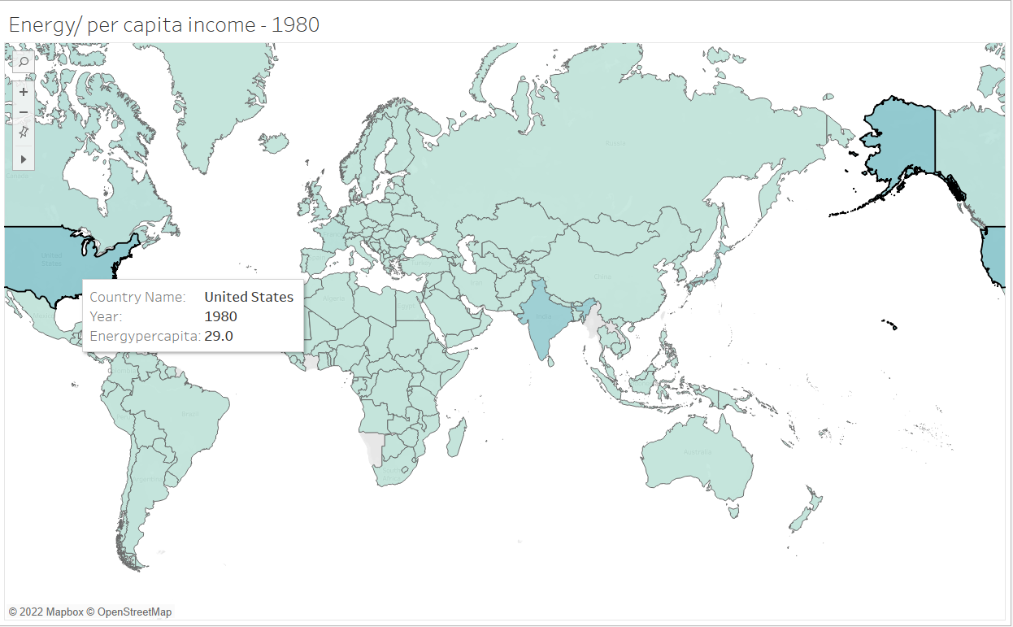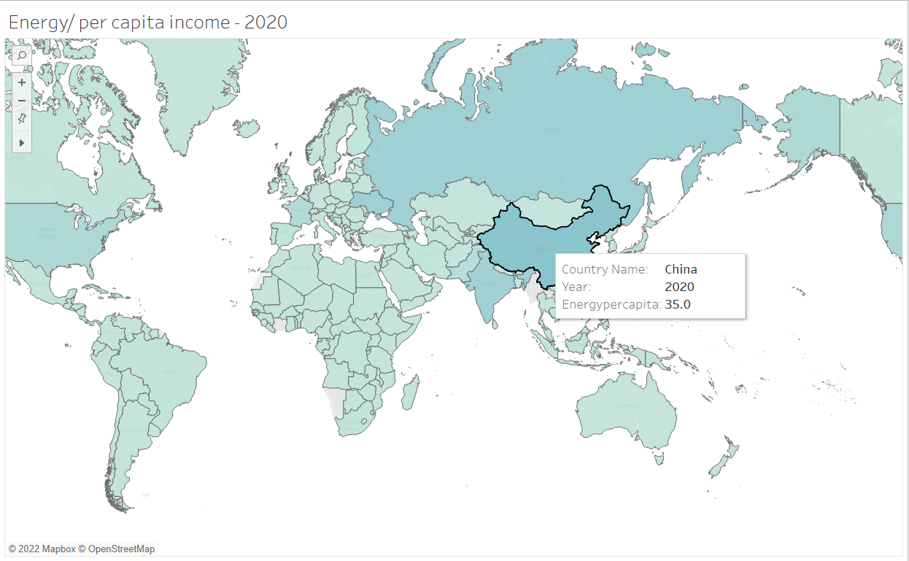
The above maps shows the nuclear energy/per capita income of each coutry for the years 1980 and 2020.
USA has the highest value of nuclear energy/per capita income during the year 1980 and chaina has the highest value in 2020.
Renewable Energy:
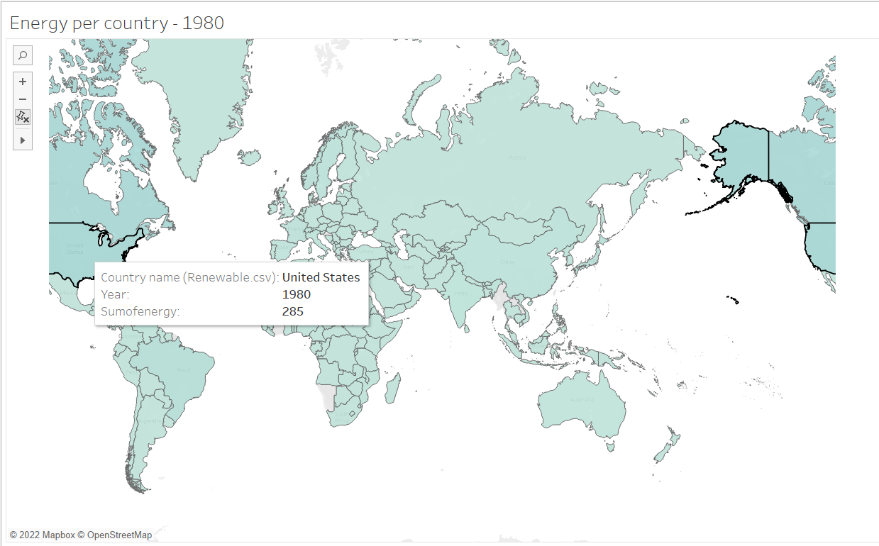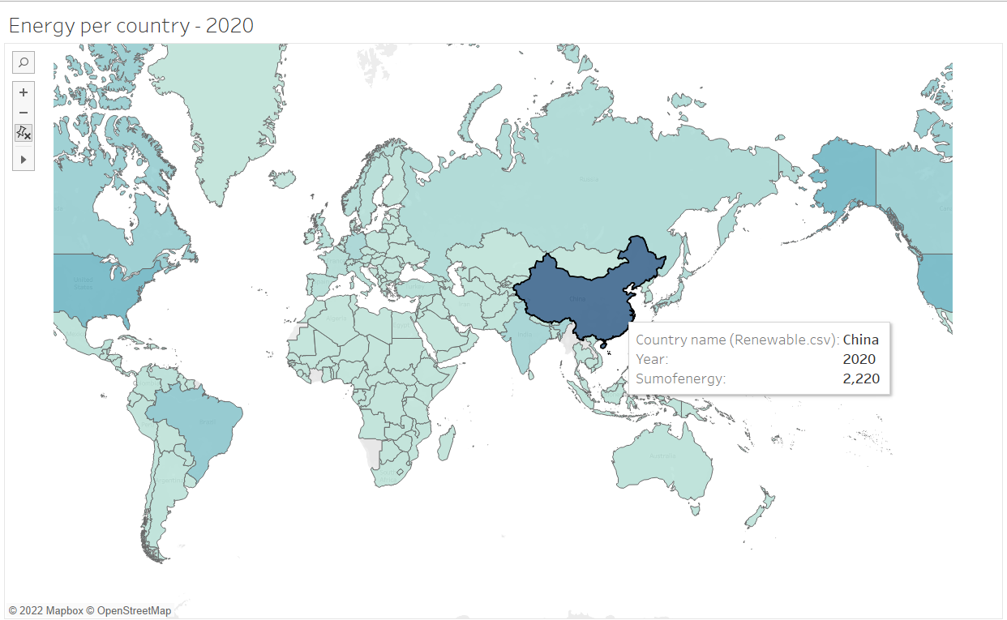
1980 2020
The above maps show total Renewable energy consumed by each country for the years 1980 and 2020.
- For the year 1980, USA has the highest Renewable energy with a value of 285 followed by Canada with a valueof 252 billion kwh.
- By the year 2020, China has become the country with highest Renewable energy consumption followed by USA and Brazil.
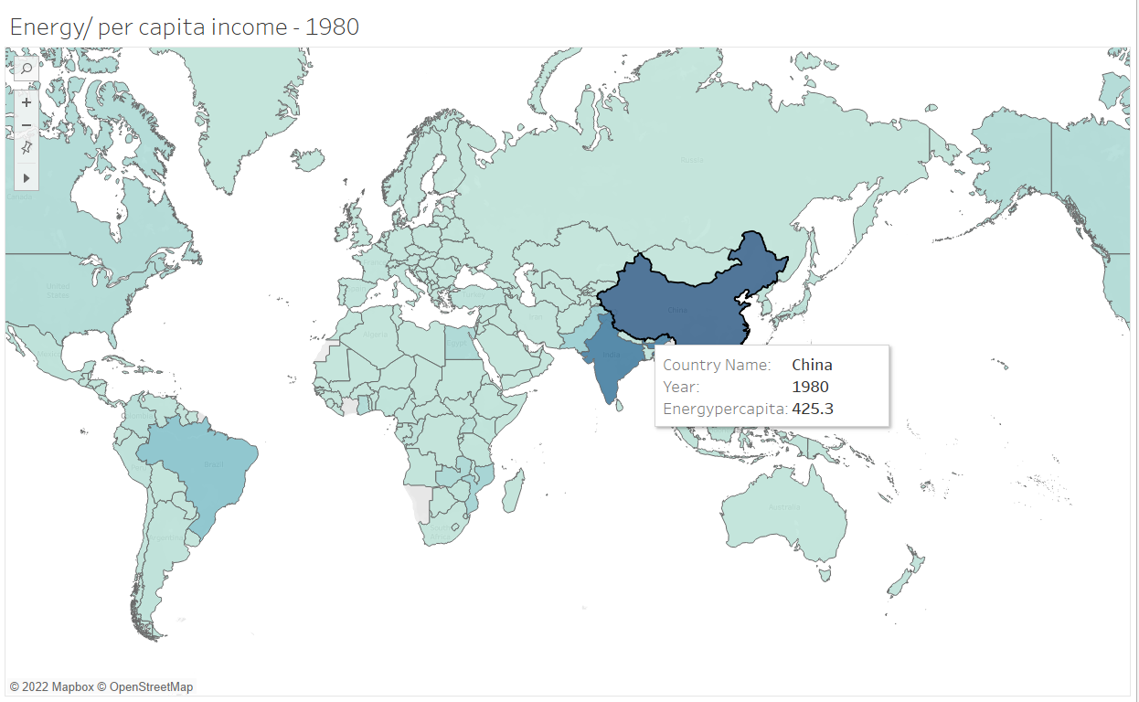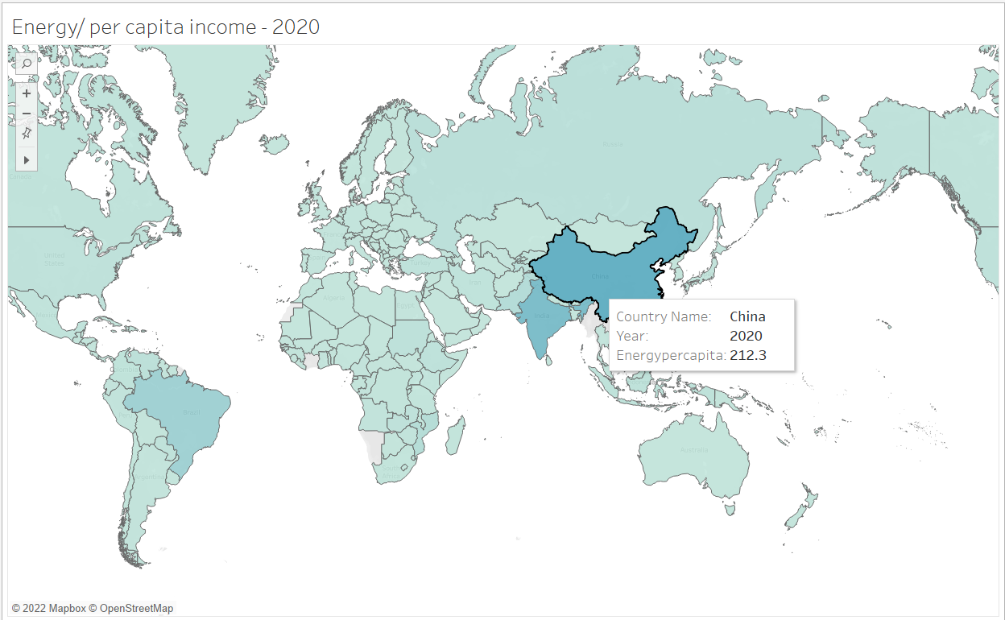
The above maps shows us the Renewable energy/per capita income for each country for the years 1980 and 2020.
China has the highest value of Nuclear energy/ per capita income for the entire span of 40 years followed by India.

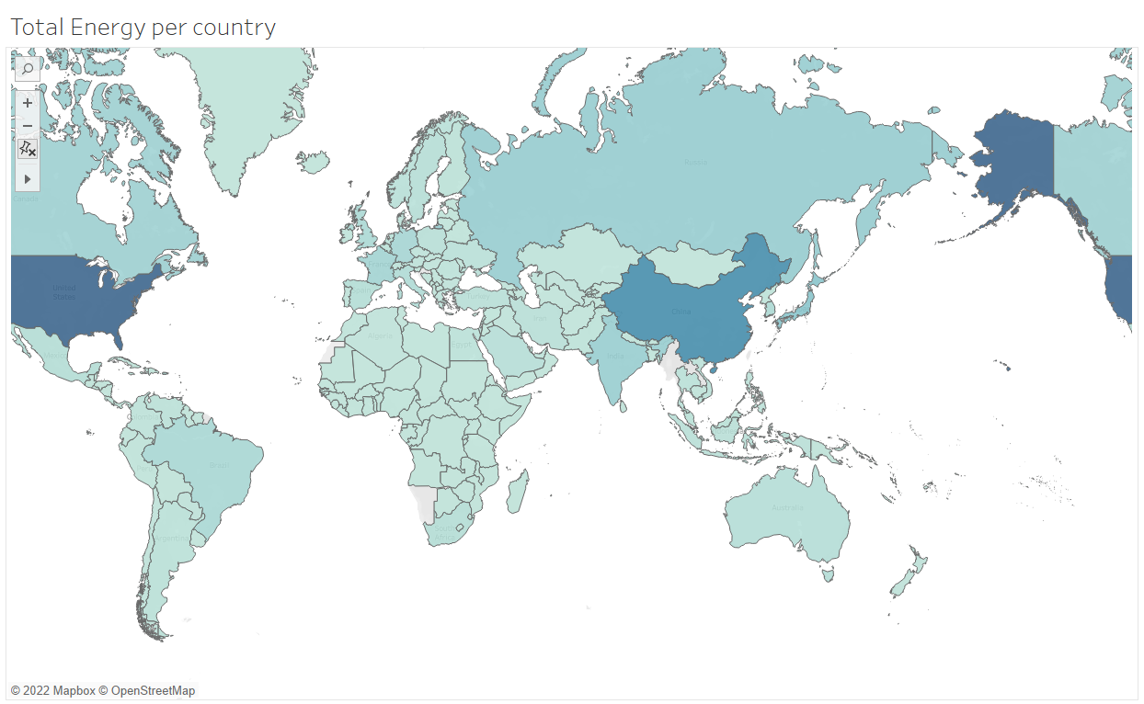

The above map shows the total energy consumed by all the countries from 1980 – 2020.
We counld see that that USA has been consuming more energy followed by china, India and Russia.

Conclusion :
The poject has given very good insights on how the energy is being consumed all over the world. The countries with highest GDP like USA, Russia, China and India has been consuming more energy than other countries. I think China has been consuming more due to industries and India is consuming more due to its population. The renewable energy production has been more in case of countries that most developed. This has to do with the abundant availability of technology. The nuclear energy is being produced only by very less countries and has not seen any growth over the span of the 40 years.

Additional research questions:

Are the International policies on the energy consumtion are effective?
What can be done decrese the energy consumption?

